A000- Afr-Nigeria-Ita Yemoo-Ife-Oni in coronation-Bronze-19th c

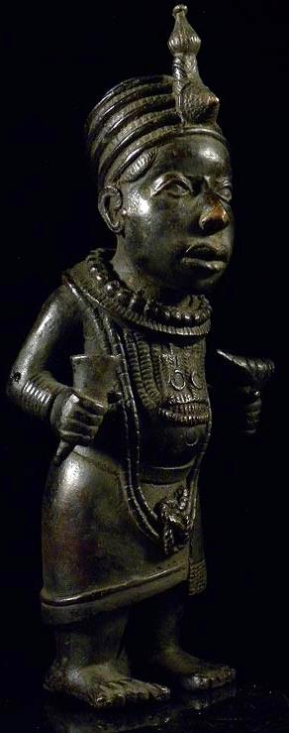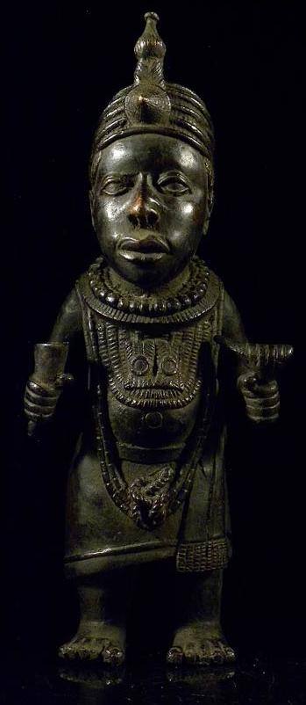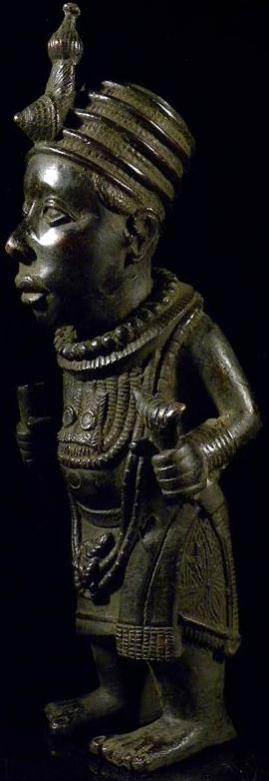

Figs. 1-3. Afr-Nigeria-Ita Yemoo-Ife-Oni in coronation-Bronze-19th c

Case No.: 6

**Accession No.**

**Formal Label:** Afr-Nigeria-Ita Yemoo-Ife-Oni in coronation-Bronze-19th c

**Display Description:**

This Ife bronze figure of an *Oni* in coronation dress (height 41 cm., weight: 3.7 kg.) is similar to one that was found at Ita Yemoo, Nigeria, in 1957 (height 48 cm.) and the upper half of the one found at the Wundomjie compound in 1939 (Shaw 1978: 134). Ife was the center of as many as 400 religious cults whose traditions were manipulated to political advantage by the Oni (king) in the days of the kingdom's greatness. Ife also lay at the center of a trading network with the north. The Oni supported his court with tolls levied on trade, tribute exacted from dependencies, and tithes due him as a religious leader. One of Ife's greatest legacies to modern Nigeria is its beautiful sculpture associated with this tradition.

The Oni was chosen on a rotating basis from one of several branches of the ruling dynasty, which was composed of a clan with several thousand members. Once elected, he went into seclusion in the palace compound and was not seen again by his people. Below the Oni in the state hierarchy were palace officials, town chiefs, and the rulers of outlying dependencies. The palace officials were spokesmen for the Oni and the rulers of dependencies who had their own subordinate officials. All offices, even that of the Oni, were elective and depended on broad support within the community. Each official was chosen from among the eligible clan members who had hereditary right to the office. Members of the royal dynasty often were assigned to govern dependencies, while the sons of palace officials assumed lesser roles as functionaries, bodyguards to the Oni, and judges.

**LC Classification:**

**Date or Time Horizon:** 19th c

**Geographical Area:** Ita Yemoo, Nigeria

**Map:**

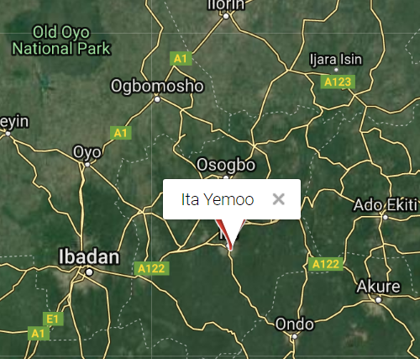

Location of Ita Yemoo, Nigeria. SOURCE: National Geospatial-Intelligence Agency, Bethesda, MD, USA, https://geographic.org/geographic_names/name.php?uni=-2800328&fid=4293&c=nigeria

**GPS coordinates:** 7° 28' 00" N; 4° 34' 00" E

**Cultural Affiliation: Ife**

**Medium: bronze**

**Dimensions:**

**Weight:**

**Condition: original**

**Provenance:**

**Discussion:**

During the fifteenth century, Oyo and Benin surpassed Ife as political and economic powers, although Ife preserved its status as a religious center even after its decline. Respect for the priestly functions of the Oni of Ife and recognition of the common tradition of origin were crucial factors in the evolution of Yoruba ethnicity. The Oni of Ife was recognized as the senior political official not only among the Yoruba but also at Benin, and he invested Benin's rulers with the symbols of temporal power.

**References:**

Shaw, Thurston. 1978. The art of Benin through the eyes of the artist, the art historian, the ethnographer and the archaeologist. In Art and society , studies in style culture and aesthetics , edited by Michael Greenhalgh and Vincent Megaw. New York: St. Martin's Press.

**Appendix:** Detailed views of statue

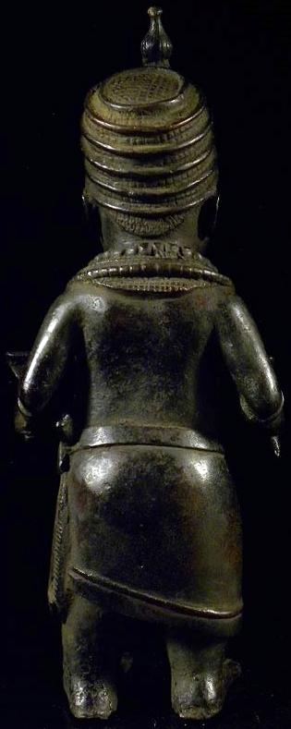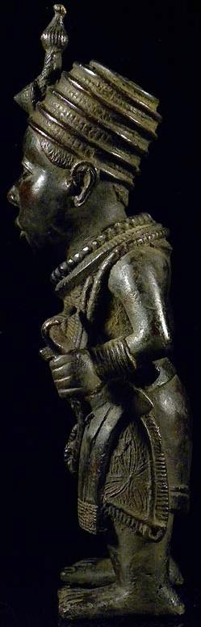

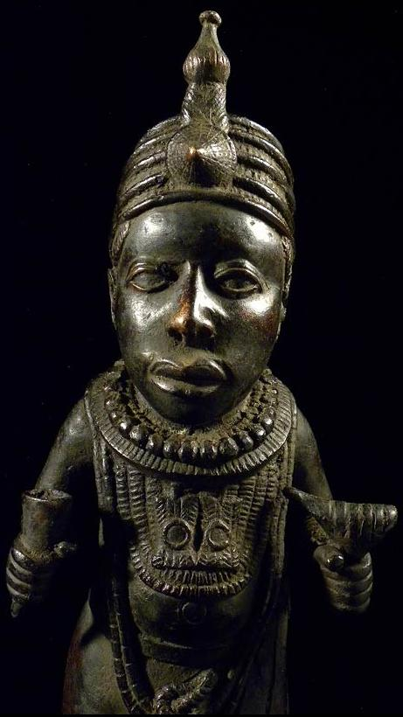

| Shipping details |
| --- |
| **Ralph J Coffman Jr**  149 Atlantic Ave  Swampscott MA 01907-2427  United States |

## Order details

|  |  |  |  |
| --- | --- | --- | --- |
| **Item title** | **Available actions** | **Shipping & handling (estimated delivery*)** | **Price** |

[Printer version](http://payments.ebay.com/ws/eBayISAPI.dll?ViewPaymentStatus&transid=1103411609015&userloginid=802-867&printerversion=true&itemid=251146341552)

|  |  |  |
| --- | --- | --- |
| Seller: | [**Member id** art-afrique](http://myworld.ebay.com/art-afrique) ( [**Feedback Score Of** 8149](http://feedback.ebay.com/ws/eBayISAPI.dll?ViewFeedback&userid=art-afrique)) | [Contact seller](http://contact.ebay.com/ws/eBayISAPI.dll?ShowCoreAskSellerQuestion&frm=3998&iid=251146341552&redirect=0&requested=art-afrique) |

|  |  |  |  |  |
| --- | --- | --- | --- | --- |
| Paid on Oct-14-12 via PayPal | | | | |
|  |  |  |  |  |

|  |  |  |  |  |  |  |  |  |
| --- | --- | --- | --- | --- | --- | --- | --- | --- |
|  | [**Item Title:**\*\* Bronze Königs Sohn Statue / Nigeria \*\***- opens in a new window or tab**](http://cgi.ebay.com/ws/eBayISAPI.dll?ViewItem&item=251146341552)  **Item Id:**251146341552 - Price: EUR 198.00  Quantity:1  Having a problem with this purchase? [We can help](javascript:;) | |  | | --- | |  | | |  |  | | --- | --- | | [View PayPal transaction**- opens in a new window or tab**](http://payments.ebay.com/ws/eBayISAPI.dll?IntermediateResolutionInfo&qs=transid%3D1103411609015%26buyerorseller%3D0%26sspagename%3DBuyTransCS%26itemid%3D251146341552&transid=1103411609015&pn=UnifiedCheckoutSummaryRedirect2PP&itemid=251146341552) |  | | | Standard Int'l Versand : **EUR 60.00**  Estimated delivery: Varies* You can [contact the seller](http://contact.ebay.com/ws/eBayISAPI.dll?ShowCoreAskSellerQuestion&frm=3998&iid=251146341552&SSpagename=PageAskSellerQuestion_VI&redirect=0&requested=art-afrique) for more information.  **Package 1 of 1**    Shipment details: [7078](javascript:;) | EUR 198.00 |



|  |  |  |  |  |
| --- | --- | --- | --- | --- |
|  | | |  | |
|  |  | |  |  |  |  |  |  |  |  |  |  |  |  |  |  |  |  |  |  | | --- | --- | --- | --- | --- | --- | --- | --- | --- | --- | --- | --- | --- | --- | --- | --- | --- | --- | | |  | | --- | | |  |  |  |  |  |  |  |  |  |  |  |  |  |  |  | | --- | --- | --- | --- | --- | --- | --- | --- | --- | --- | --- | --- | --- | --- | --- | | |  |  | | --- | --- | | Subtotal: | EUR 198.00 | |  | | | Shipping & handling: | EUR 60.00 | |  | | |  | | |  | | | Total: | EUR 258.00 | | | | | |  |